7-1 Final Project Reflection

Annette Baez
Southern New Hampshire University
CS-330: Comp Graphic and Visualization
Professor Thomas Gerlach
April 19, 2026

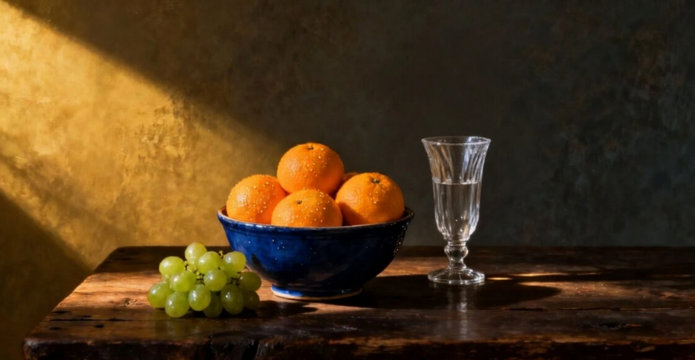
I selected the still-life photograph because it contained a variety of object types that mapped cleanly to the available OpenGL primitives. The blue ceramic bowl is a natural fit for an inverted tapered cylinder with a torus rim. The oranges and grapes are spheres of different scales. The drinking glass is another inverted tapered cylinder with a torus base ring. The flat table and wall are planes. This gave me coverage of four distinct object types, while keeping the polygon count well under the 1,000-triangle limit per object.
For functionality, the bowl and glass are each built from two objects combined into a recognizable object. Textures were chosen to match each surface: orange peel, grape skin, blue ceramic glaze, wood grain, and concrete, while the glass uses a solid translucent color since a texture would obscure its transparent appearance. Four lights were used to recreate the dramatic diagonal sunlight in the photo, with a warm golden key light from the upper left and three fill lights preventing the shadow side from going completely black.
The virtual camera is controlled through both keyboard and mouse input. The WASD keys move the camera forward, backward, left, and right along the X and Z axes. The Q and E keys move the camera up and down along the Y axis, allowing the user to view the scene from above or below. These are processed in each frame inside the ProcessKeyboardEvents() using GLFW key polling with gDeltaTime, ensuring movement speed stays constant regardless of frame rate.
Mouse movement controls the camera orientation. As the mouse moves left and right it adjusts the yaw, and up and down adjusts the pitch, allowing the user to look around the scene without changing position. This is handled in the Mouse_Position_Callback() static method, which GLFW calls automatically whenever the cursor moves. A first-mouse guard prevents a sudden jump in orientation when the cursor is first captured. The scroll wheel adjusts the camera movement speed via Mouse_Scroll_Callback(), giving the user fine control over how fast the camera travels. Finally, pressing O switches the viewpoint to orthographic projection for a flat 2D view of the scene, and pressing P returns to perspective projection, handled in ProcessKeyboardEvents() by toggling the b0rthographicProjection flag.
The program is organized into several custom methods that each handle one specific responsibility, making the code easier to read, maintain, and reuse. SetTransformations() takes scale, rotation, and position values and builds the full model matrix, then sends it to the shader. Every shape in the scene calls this one function instead of repeating the matrix math each time. If the transformation logic ever needs to change, it only needs to change in one place. SetShaderTexture() and SetShaderColor() are mutually exclusive methods for applying surface appearance. Calling SetShaderTexture() enables texture sampling and binds the correct texture sloy by tag name. Calling SetShaderColor() disables texture sampling and sends a solid color instead. This is used for the glass, which uses color rather than texture. Both functions abstract the raw shader uniform calls, so RenderScene() reads clearly.
SetShaderMaterial() looks up a named material from the m_objectMaterials vector and sends its ambient, diffuse, specular, and shininess values to the shader. Since the materials are defined by tag strings, the same materials can be applied to any number of objects just by passing the same tag, and changing a material’s properties in DefineObjectMaterials() updates every object using it automatically.
SetupSceneLights() uses a loop over the g_SceneLights array defined in the anonymouse namespace. This means all light data lives in one place and adding or modifying a light requires no changes to the look itself. Together these functions keep RenderScene() focused purely on describing what obejcts exist and where they are, while the how of rendering is handled by the helper methods.

References
OpenGL Tutorial. (2023). Tutorial 8: Basic shading.
https://www.opengl-tutorial.org/beginners-tutorials/tutorial-8-basic-shading/

Shreiner, D., Sellers, G., Kessenich, J., & Licea-Kane, B. (2013).
OpenGL programming guide: The official guide to learning OpenGL, version 4.3 (8th ed.). Addison-Wesley.

Singh, D. (2019). G-truc creation: OpenGL mathematics (GLM).
https://glm.g-truc.net/0.9.9/index.html

